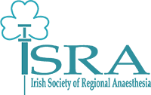
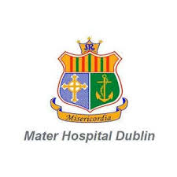
Irish Society of Regional Anaesthesia
Mater Misericordiae University Hospital-Dublin
Ultrasound guided regional anaesthesia foundation course
Pillar Centre
Saturday April 09, 2022

Programme:
Pillar center for transformative healthcare (old theatres):
- 09.00-09.15- Set up, Registration, and Group Allocation
- 09.15-09.30 -Welcome and official opening of the course - Dr Georgi Valchev
- 09.30-10.00 -Introduction to RA – Dr Padraig O’Scanaill
- 10.00- 10.30- Interscalene Brachial plexus block - Dr Su Ng
- 1o.30- 11.00 - Axillary brachial plexus block -Dr Viera Husarova
- 11.00-11.30- Coffee break
- 11.30-12.00- Femoral nerve block -Dr Bill Walsh
- 12.00- 12.30- Popliteal nerve block- Dr Ryan Howle
- 12.30- 13.15 - Lunch break

Pillar center for transformative healthcare (old theatres):
- 13.15- Station 1- Interscalene block (30 minutes)
- 13.45- Station 2- Axillary block (30 minutes)
- 14.15 Station 3- Femoral block (30 minutes)
- 14.45 -15.00 Tea break
- 15.00- Station 4- Popliteal block (30 minutes)
- 15.30- Station 5- Phantoms and Needling (30 minutes)
- 16.00- Wrap -up, Q and A, Feedback & Finish

Faculty Allocations:
- Station 1 - Dr Su Ng
- Station 2 - Dr Viera Husarova
- Station 3 - Dr Padraig O’Scanaill
- Station 4 - Dr Ryan Howle
- Station 5 – Dr Bill Walsh

