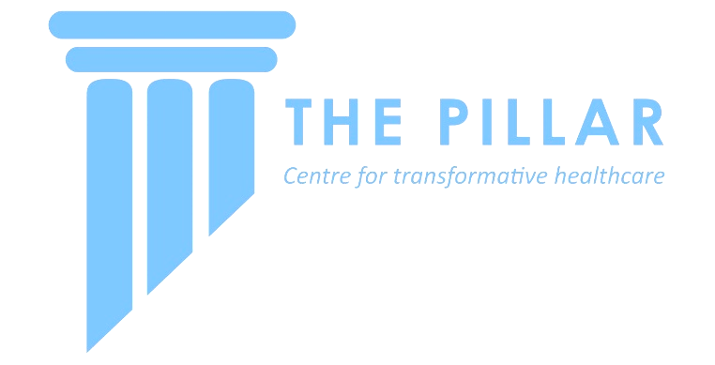
Open Call: THE PILLAR CENTRE research project Fund
Summer 2023

Details of this Scheme
- Funding available for 8x Pillar Centre Student Fellowships of €2,500 each to conduct selected research projects
- Mater Misericordiae University Hospital (MMUH) based projects to be conducted over 8 weeks in Summer 2023 (€2500 to cover student’s salary for their full-time research project)
- Applications for projects invited from all MMUH staff (involving a permanent member of staff) by 5pm on Friday December 2nd
Who can apply?
This call is open to all MMUH staff across all specialities and disciplines who have a research project which can be conducted by a Summer Student under supervision. A member of the Study Team making the application must be employed in MMUH during the project timeframe and available to provide supervision. Successful project teams may either choose their own Summer Student, or include their project in a combined advertisement and select from applicants.

How to apply:
Please complete the 2-page application form detailing your proposed project and submit for panel review by the closing date: 5pm on Friday 2nd December. All application forms will be reviewed, and applicants will be informed of decisions by December 16th.

Link to application form and additional information:
https://thepillarcentre.ie/programmes/research/research-project-fund-2023/

Assistance:
If you have an idea and would like help developing it out and designing your proposal, please email MMUHresearch@mater.ie to book a consultation slot at a drop-in clinic (which will be held Thurs 17th and Friday 18th November)

Application form (2-page limit, font size 11)

Project title:

Project Summary (250 words max): Please provide a simple overview of your proposed project.

Project Background: Please provide an introduction to your project. You may include the potential impact of the project, or what data, knowledge or resources are available within the study team which make the project unique or valuable etc.

Project Methods and Timeline: Please provide a detailed breakdown of how the student will undertake the project. Feel free to include a Gannt chart or a description of how the 8 weeks will be spent. Please include if research ethics is required and whether these are already prepared/submitted/approved. Additionally, please provide any pilot data if available, or a clear indication that the objectives of your project are achievable e.g. a database containing required variables exists for past 4 years, images required for study are available through NIMIS for 30 patients etc. (We want to ensure the student will be able to begin their project immediately in week 1).

Project Deliverables: Please provide an indication of the project outputs e.g. database, presentation at specific conference, publication in specific journal. Feel free to use images or schematics (within your 2 page limit) to explain your project if required. Additionally, please provide the impact that successful delivery of this project may have e.g. new knowledge, resource planning, pilot data for a larger study or grant application, establishing a collaboration to build future research projects etc.

Study team: Please include all members of the study team (it is not necessary to have a student already in place) and highlight any necessary experience or skills which will facilitate successful delivery of proposed project.

References or additional information: Please include relevant references where appropriate

Please note that project proposals will be evaluated based on the merit of the project description, the likely impact of successful project delivery (e.g., a project targeting gathering pilot data for a grant submission or towards a journal publication) realistic goals for an 8 week summer student and adequate resources (e.g., databases, samples, images etc.).

